SILVER MAPLE
Acer saccharinum
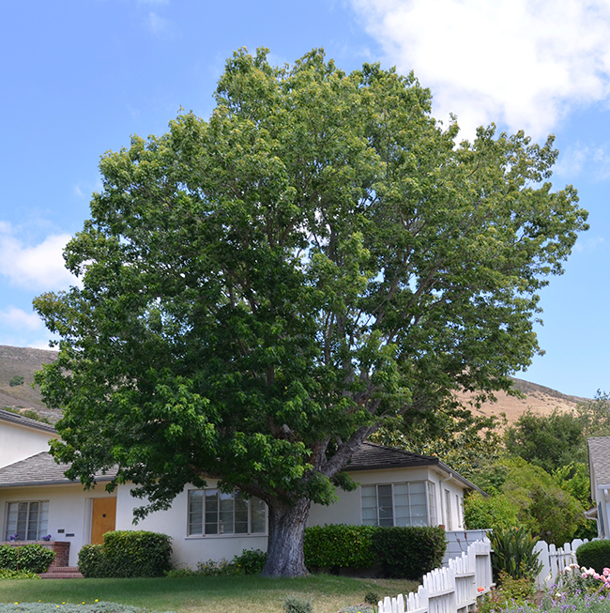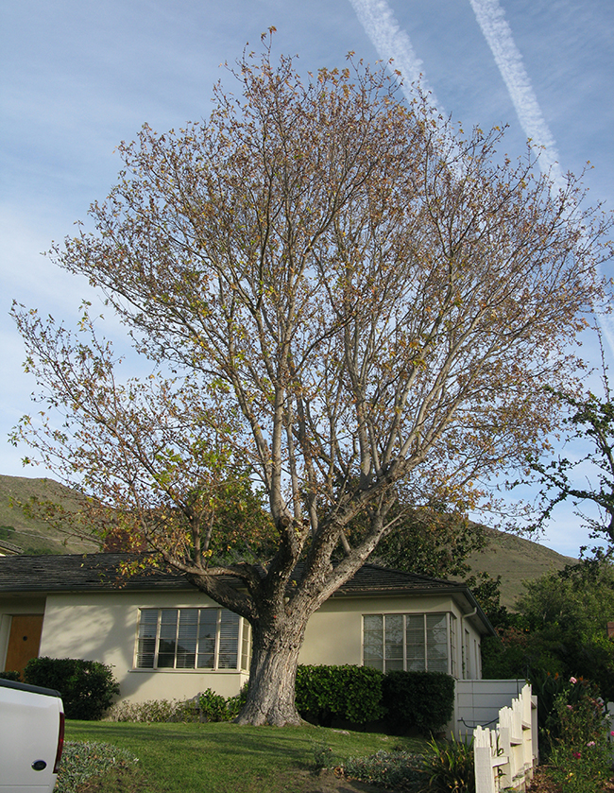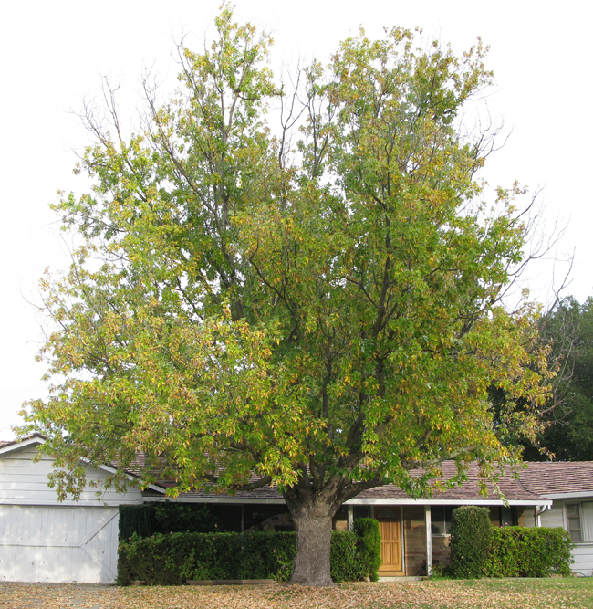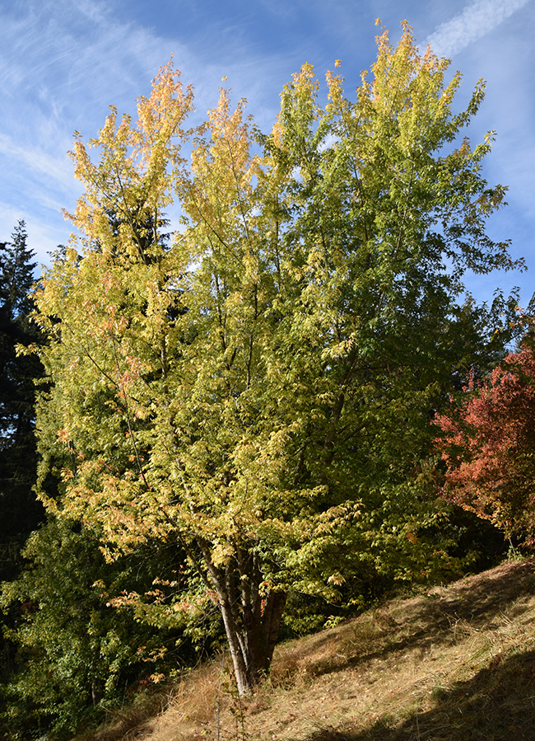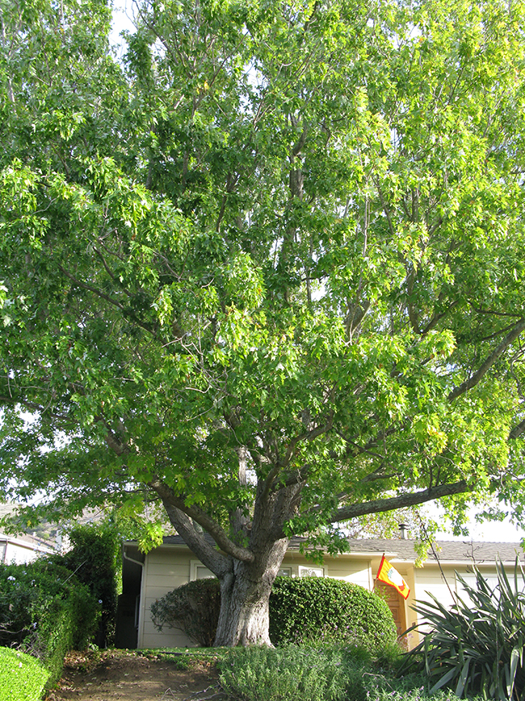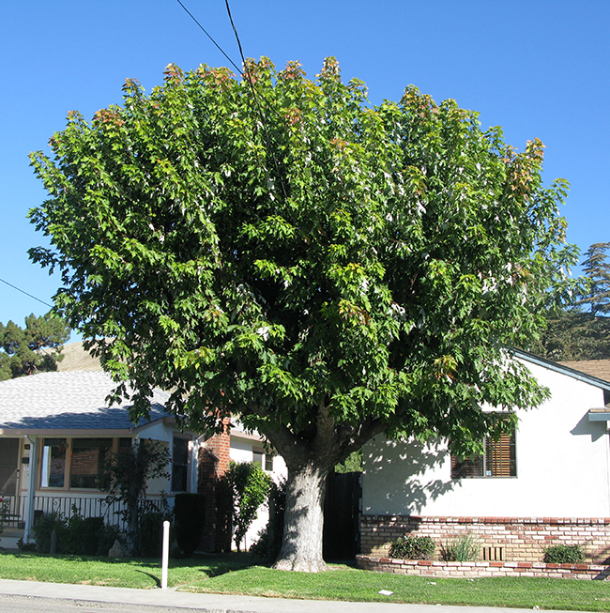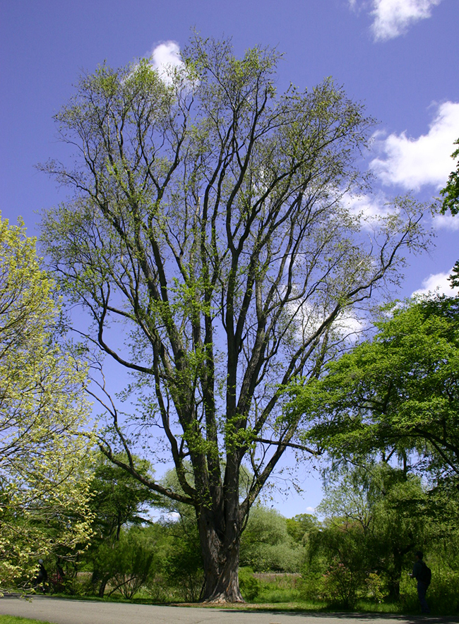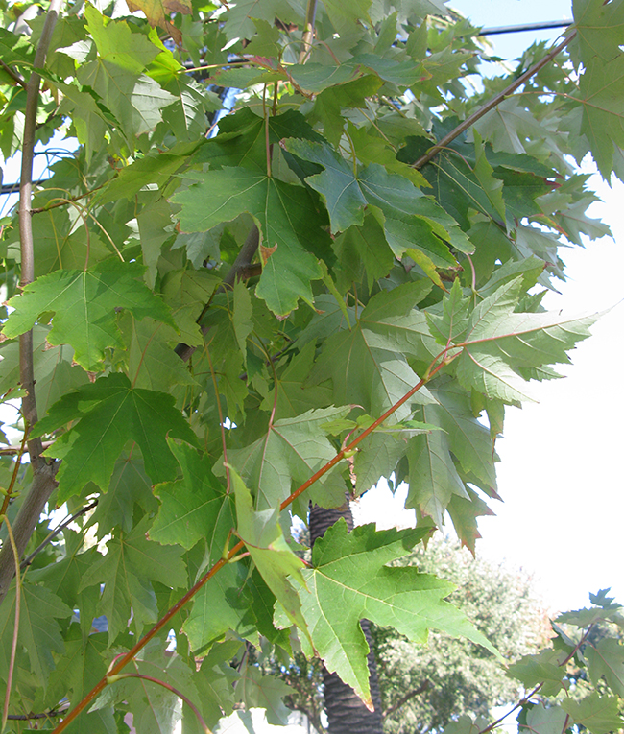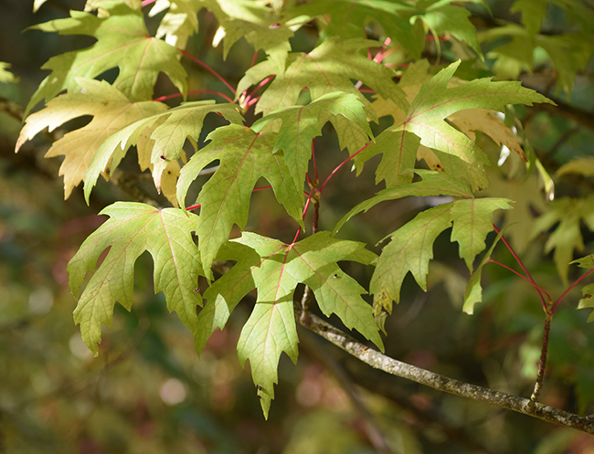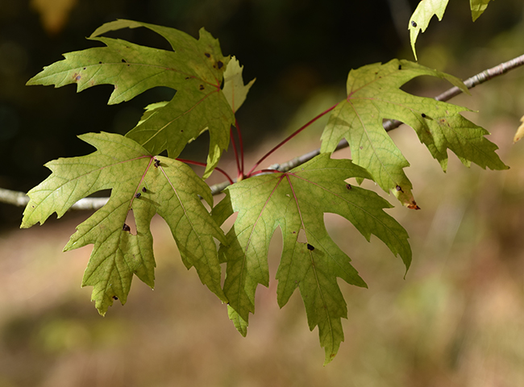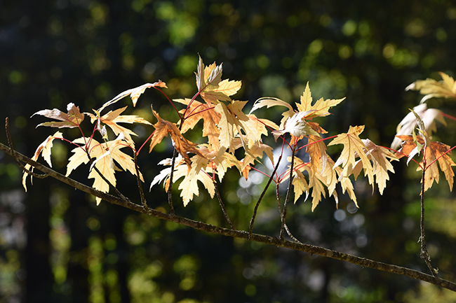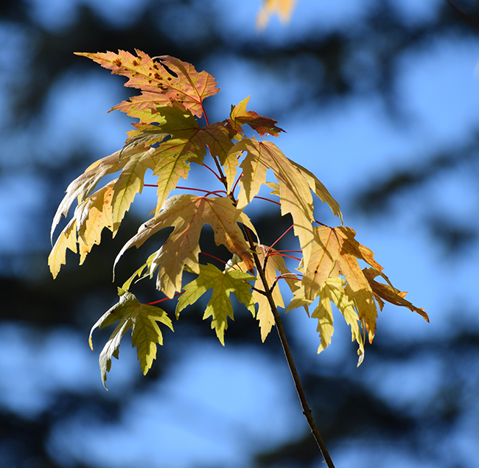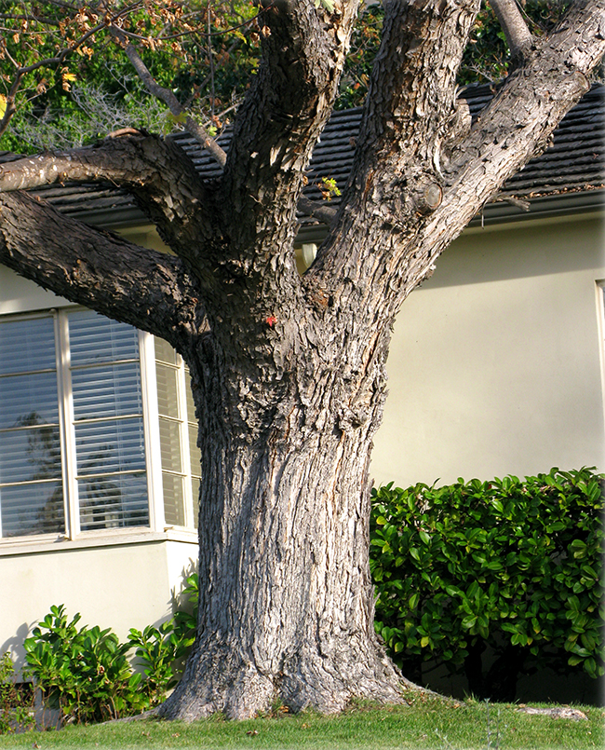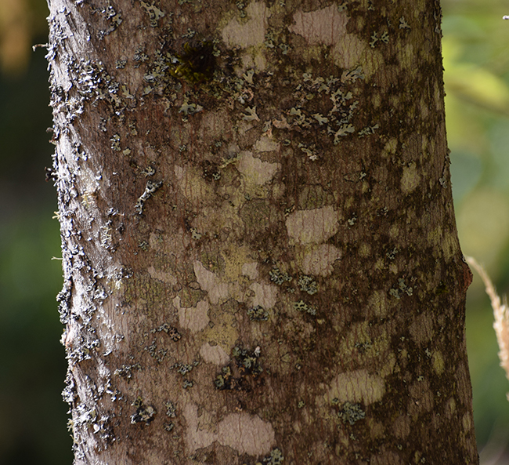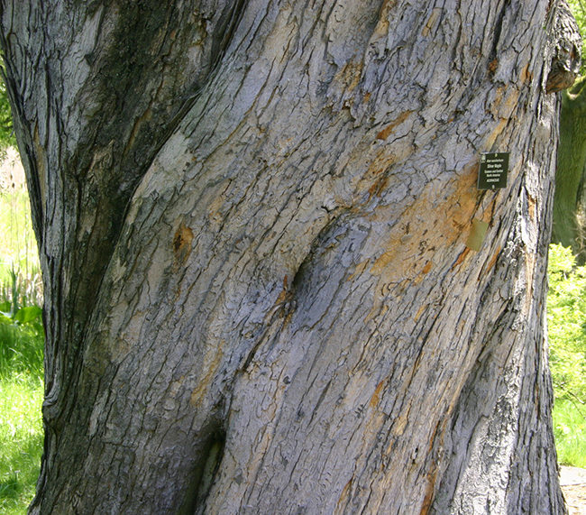
Photo Locations: Hoyt Arboretum - Portland, OR, Berkeley Arboretum - Berkeley, CA, Saratoga, CA and San Luis Obispo, CA
See all Acer.

General Notes
Develops chlorosis in alkaline soils. Underside of leaf is silvery white. Susceptible to heart rot.
Native to Eastern North America.
Family: Sapindaceae
Previously listed in the Aceraceae family.

Additional Common Names
SILVER MAPLE, SILVER LEAF MAPLE, SOFT MAPLE, WATER MAPLE

Tree Characteristics
Erect or Spreading and requires ample growing space.
Oval or Rounded Shape.
Has Deciduous foliage.
Height: 40 - 100 feet.
Width: 50 feet.
Growth Rate: 36 or More Inches per Year.
Longevity 50 to 150 years.
Leaves Palmate, Light Green, Red, Gold, Orange or Multicolored, Deciduous.
Flowers Inconspicuous. Green or Yellow. Flowers in Spring. Has separate male and female flowers on the same tree (monoecious).
Beige or Brown Winged Seed, Large (1.50 - 3.00 inches), fruiting in Summer.
Bark Light Gray or Red Brown, Exfoliating.
Shading Capacity Rated as Moderate in Leaf.
Shading Capacity Rated as Moderate out of Leaf.
Litter Issue is Dry Fruit, Twigs and Bark.

Tree Site Conditions & Constraints
Sunset Zones 1 - 9, 12, and 14 - 24.
USDA Hardiness Zones 4 - 9.
Exposure Full Sun to Partial Shade.
Wet to Moist Soil.
Clay, Loam or Sand Texture.
Highly Acidic to Slightly Alkaline Soil pH.
Seaside Tolerance is Good in Mild Zone.

Pests & Disease Information
Susceptible to Aphids, Beetle Borers and Scales, Armillaria, Root Rot, Sooty Mold and Verticillium Wilt.

Health, Safety & Environmental Concerns
Branch Strength Rated as Weak to Medium Weak
Root Damage Potential Rated as High.
Allergy Health Hazard.
Biogenic Emissions considered Moderate.
Desirable Wildlife Plant.

Special Uses & Values
Riparian.

