Gleditsia triacanthos f. inermis 'Skycole' SKYLINE
Back to Previous Page
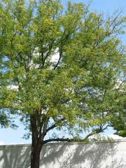
More Images
Common Name: honey locust
Type: Tree
Family: Fabaceae
Zone: 3 to 8
Height: 35.00 to 45.00 feet
Spread: 25.00 to 35.00 feet
Bloom Time: May to June
Bloom Description: Greenish-white
Sun: Full sun
Water: Medium
Maintenance: Medium
Suggested Use: Shade Tree, Street Tree
Flower: Showy
Tolerate: Deer, Drought, Clay Soil, Black Walnut, Air Pollution
Garden locations

Culture
Best grown in organically rich, moist, well-drained soils in full sun. Tolerant of a wide range of soils. Also tolerant of wind, high summer heat, drought and saline conditions.

Noteworthy Characteristics
Gleditsia triacanthos, commonly called honey locust, is native from Pennsylvania to Iowa south to Georgia and Texas. It typically grows 60-80’ (less frequently to 120’) tall with a rounded spreading crown. Trunk and branches have stout thorns (to 3” long) that are solitary or three-branched. Inconspicuous, greenish yellow to greenish white flowers appear in racemes in late spring (May-June in St. Louis). Flowers are followed by long, twisted and flattened, dark purplish-brown seedpods (to 18” long) which mature in late summer and persist well into winter. Seedpods contain, in addition to seeds, a sweet gummy substance that gives honey locust its common name. Species plants are generally not sold in commerce today because the thorns and seedpods are considered to be significant liabilities.
Forma inermis is a thornless variety (inermis from Latin means unarmed) that occurs naturally in the wild. It grows to the same height as the thorny species plants. Cultivars of G. triacanthos which are sold in commerce today are all cultivars of f. inermis (no thorns and in many cases no seedpods make them preferred landscape plants). Pinnate to bipinnate dark green leaves with ovate leaflets (1/2” to 1 1/2” long) cast a sun-dappled shade. Leaves turn an attractive yellow in fall.
Genus name honors Johann Gottlieb Gleditsch (1714-1786), director of the Botanical Garden, Berlin.
Specific epithet comes from the Greek acantha meaning thorn and tri meaning three in reference to the three-branched thorns on species plants.
SKYLINE ('Skycole') features pyramidal growth with a central leader. It is a thornless and nearly seedless variety that typically grows to 40-45' tall. Pinnate to bipinnate dark green leaves with ovate leaflets (1/2” to 1 1/2” long) cast a sun-dappled shade. Leaves turn an attractive yellow in fall. US Plant Patent 1,619 was granted July 16, 1957.

Problems
Honey locust is susceptible to a large number of potential disease problems, including leaf spot, canker, witches’ broom, powdery mildew and rust. Borers and webworms are common insect problems in some areas. Bagworms, plant bug, leafhopper and leaf miner may appear. Watch for spider mites.

Garden Uses
A thornless and nearly seedless variety that is recommended for lawns and streets.
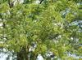 | 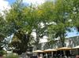 | 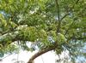 | 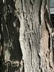 | 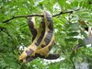
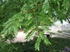 | 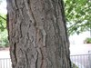 | 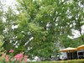 | 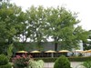 | 