GREEN MOUNTAIN SUGAR MAPLE
Acer saccharum 'Green Mountain'
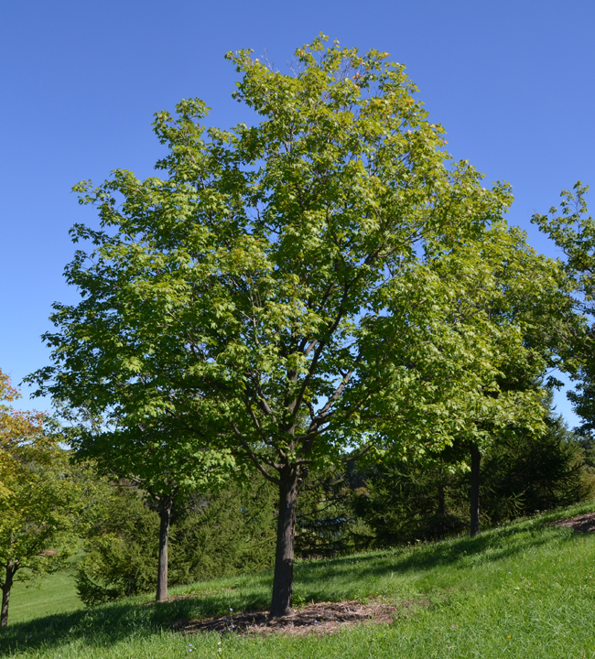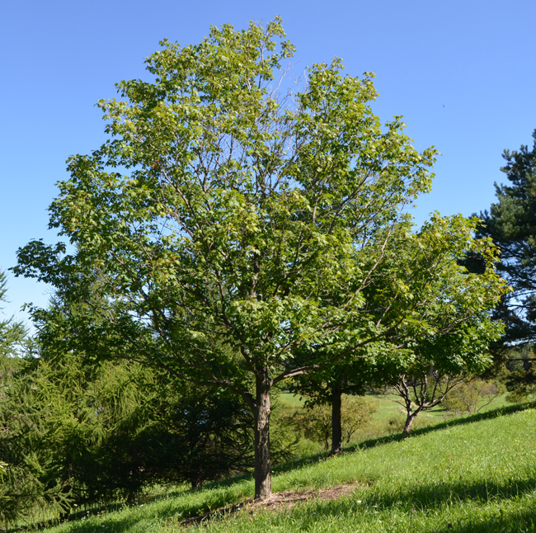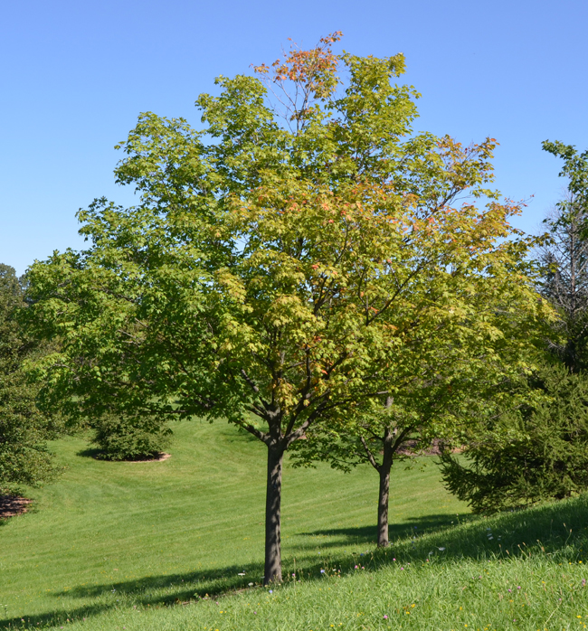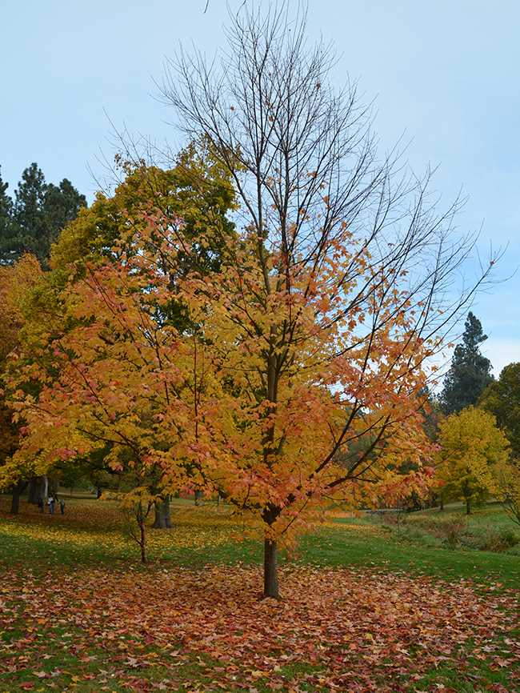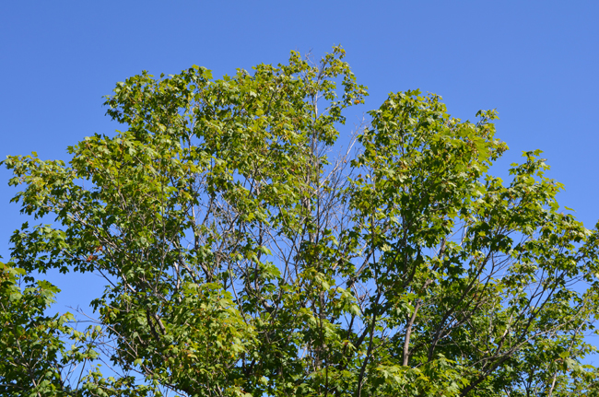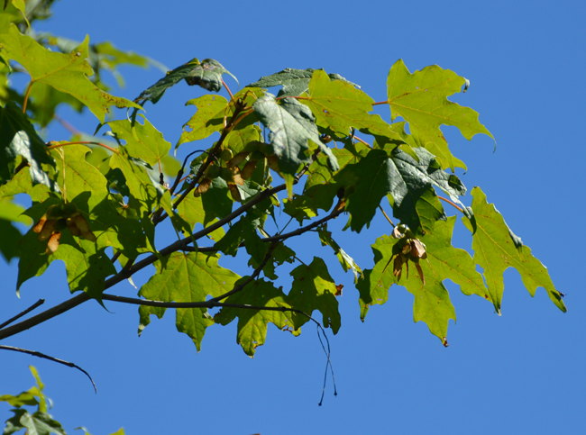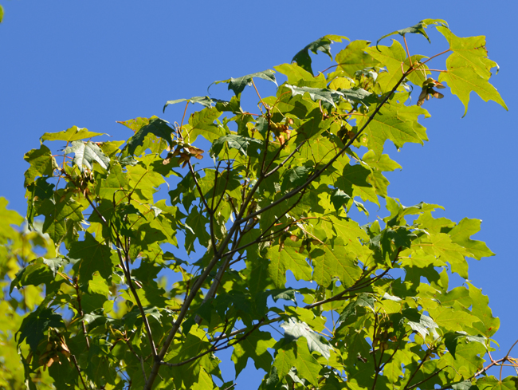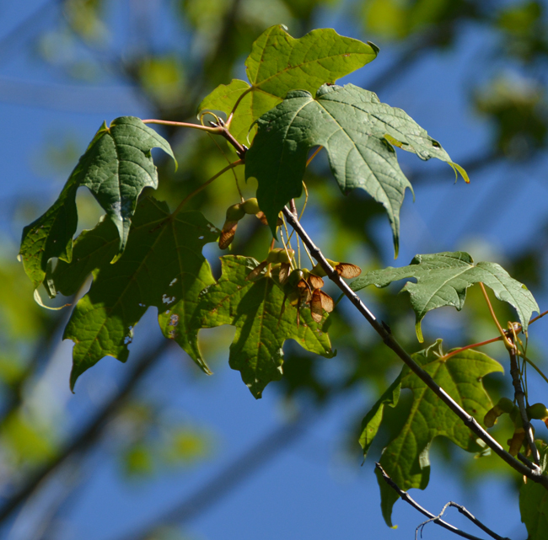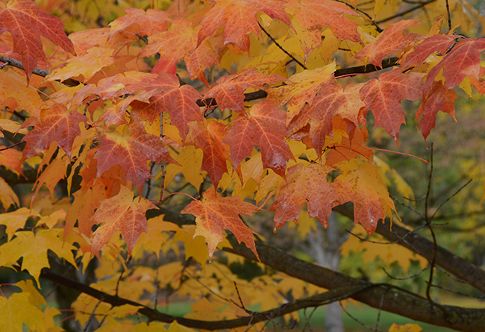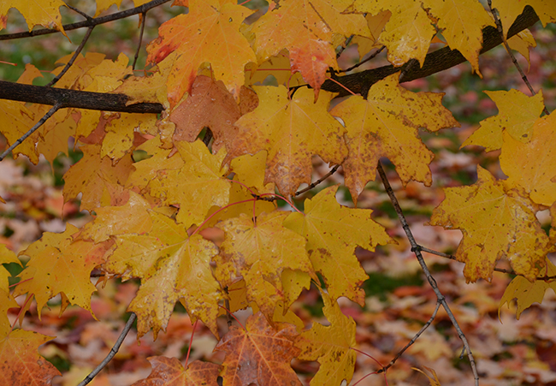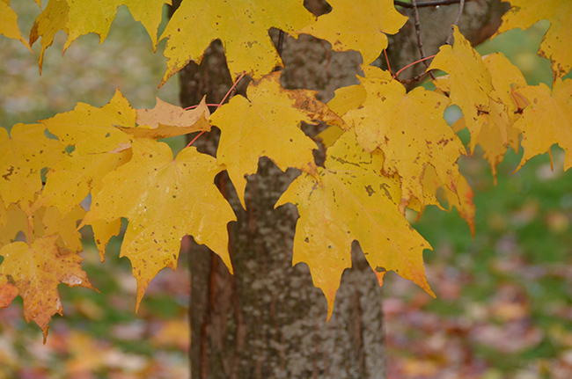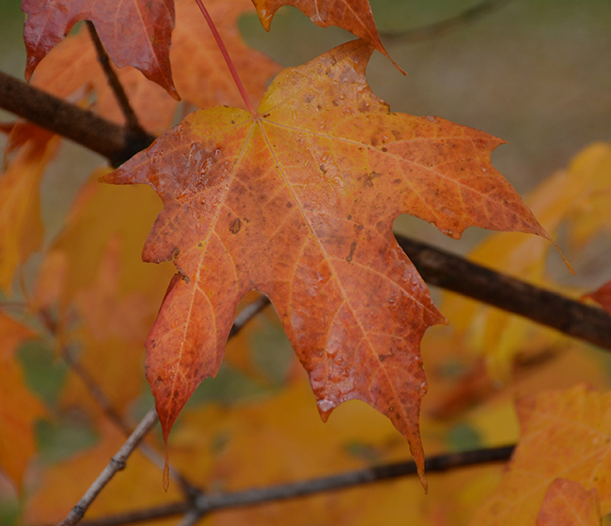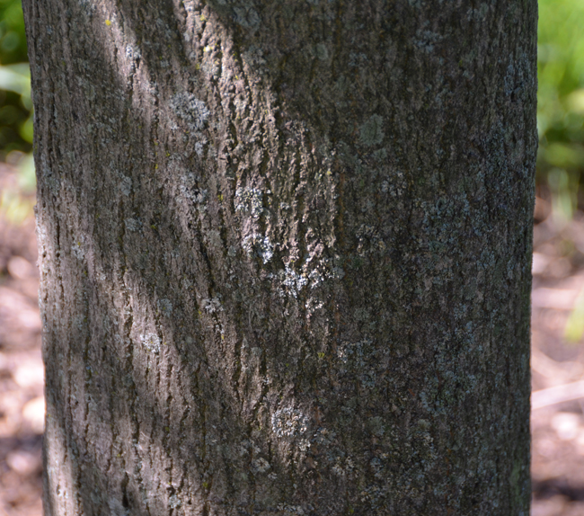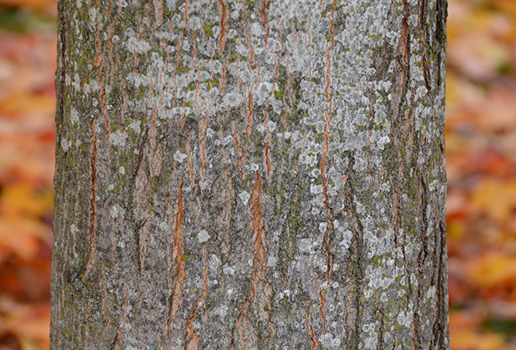
Photo Locations: Morton Arboretum - Lisle, IL and Finch Arboretum - Spokane, WA
See all Acer.

General Notes
Tolerant of heat and drought.
Family: Sapindaceae
Previously listed in the Aceraceae family.

Tree Characteristics
Erect or Spreading and requires ample growing space.
Oval or Rounded Shape.
Has Deciduous foliage.
Height: 40 - 65 feet.
Width: 35 - 50 feet.
Growth Rate: 24 to 36 Inches per Year.
Longevity 50 to 150 years.
Leaves Palmate, Medium Green, Gold, Deciduous.
Flowers Inconspicuous. Green or Yellow. Flowers in Spring. Has separate male and female flowers on the same tree (monoecious).
Brown Winged Seed, Medium (0.50 - 1.50 inches), fruiting in Summer.
Bark Dark Gray, Furrowed, Ridged or Scaly.
Shading Capacity Rated as Dense in Leaf.
Shading Capacity Rated as Moderate out of Leaf.
Litter Issue is Dry Fruit.

