OCTOBER GLORY RED MAPLE
Acer rubrum 'October Glory'
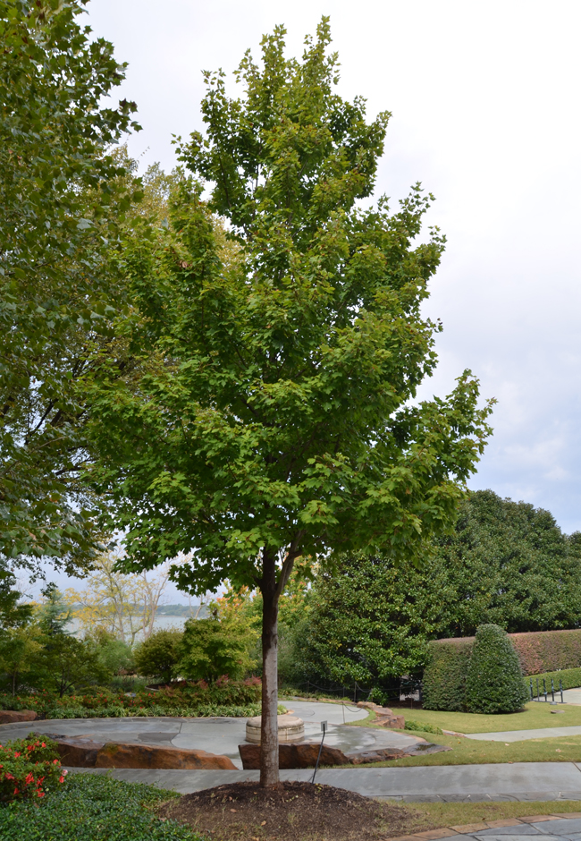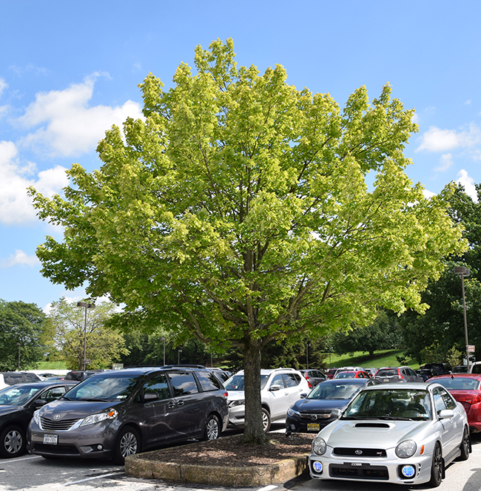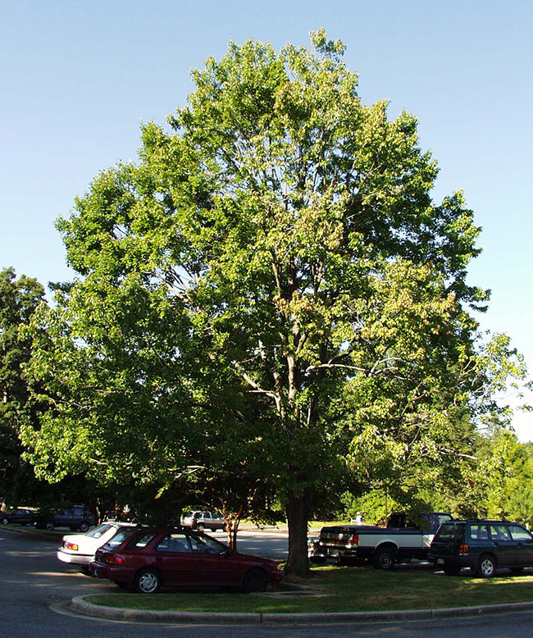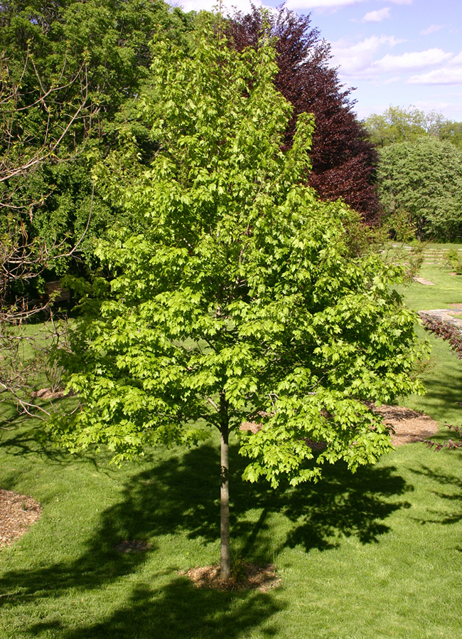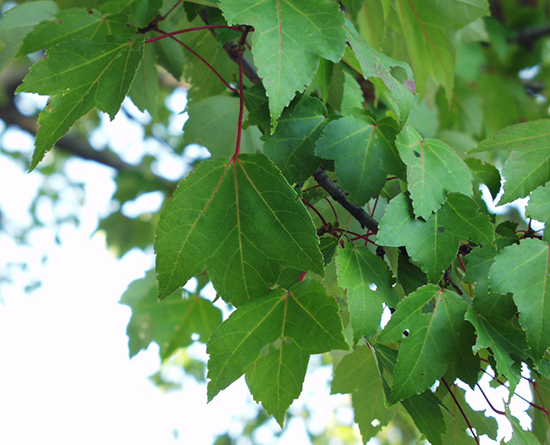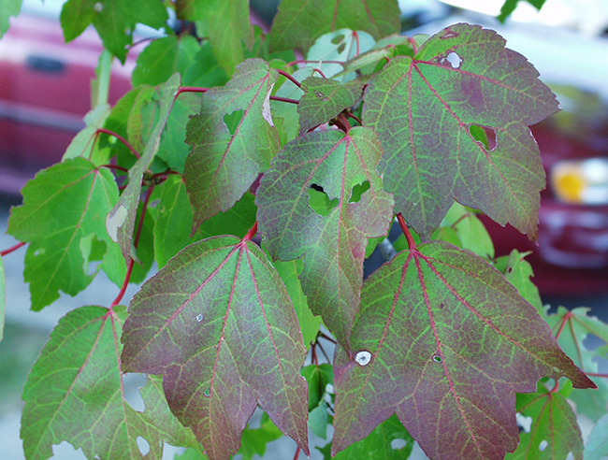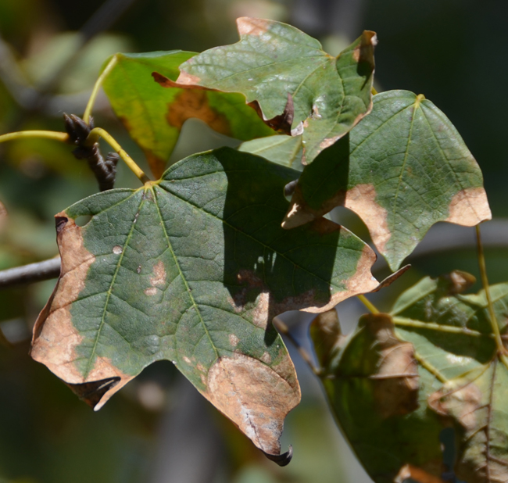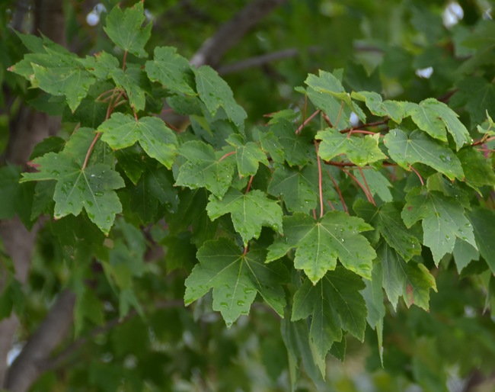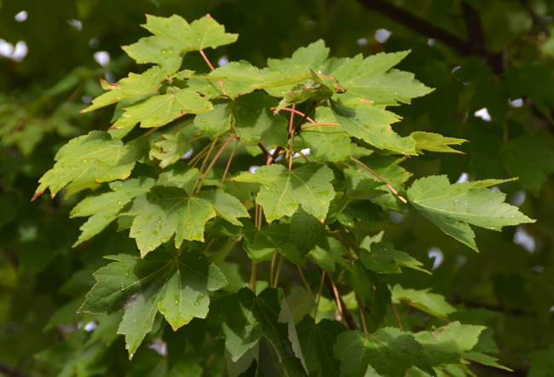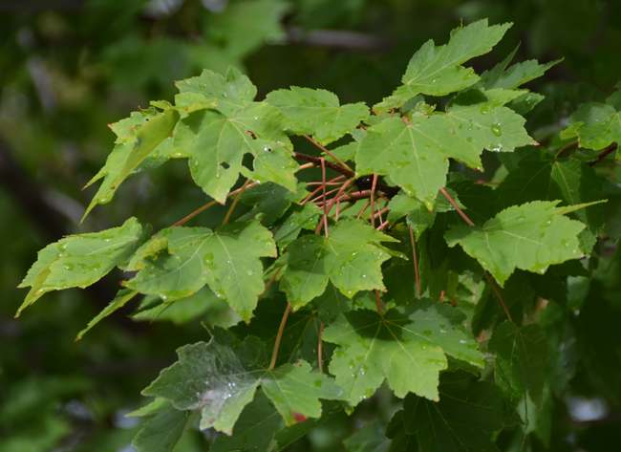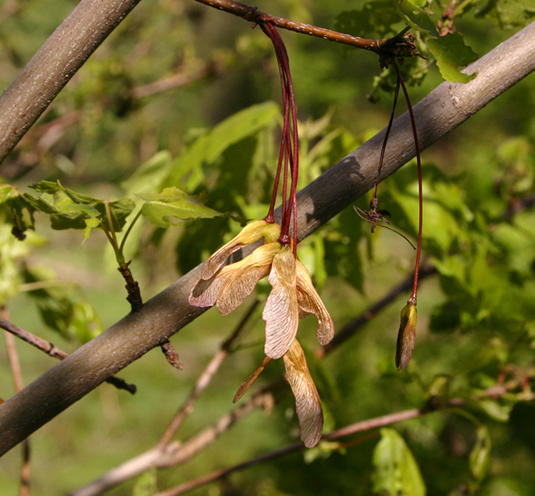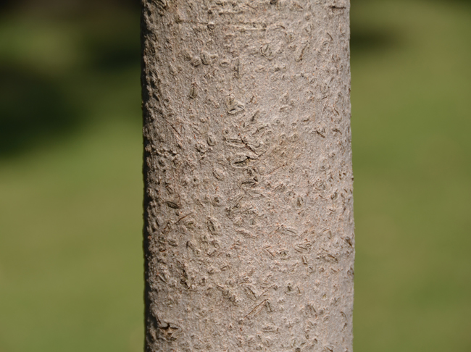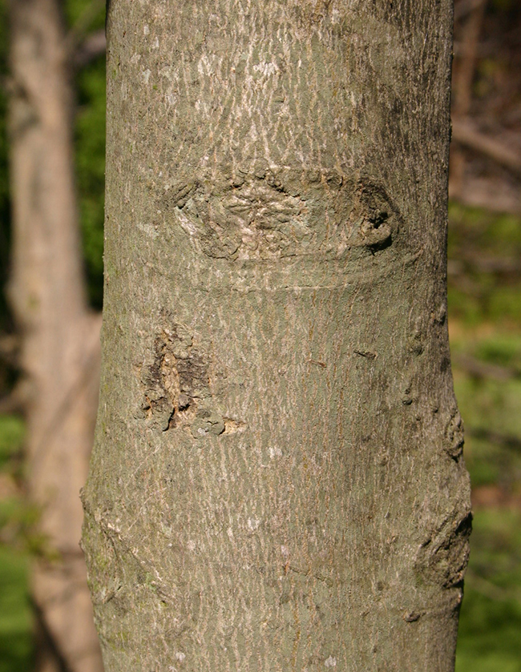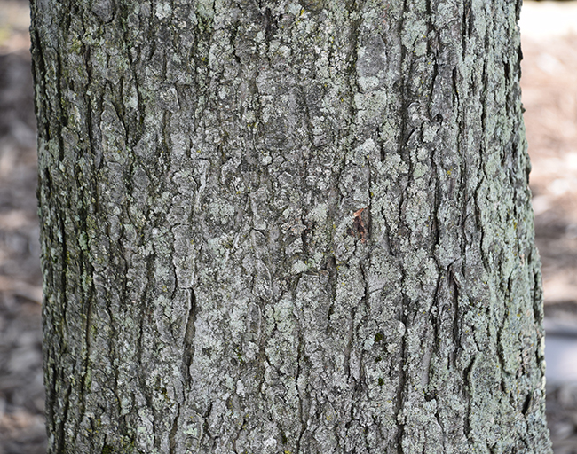
Photo Locations: Longwood Gardens - Kennette Square, PA, Dallas Arboretum - Dallas, TX, National Arboretum - Washington, D.C. and Arnold Arboretum - Boston, MA.
See all Acer.

General Notes
Branches droop but resist breakage. 'October Glory' is a female cultivar, well noted for its fall color.
Trees may be referred to as male or female.
Family: Sapindaceae
Previously listed in the Aceraceae family.

Tree Characteristics
Oval or Rounded Shape.
Has Deciduous foliage.
Height: 40 - 50 feet.
Width: 25 - 35 feet.
Growth Rate: 24 or More Inches per Year.
Leaves Lobed and Palmate, Green, Red, Gold or Orange, Deciduous.
Flowers Showy. Red. Flowers in Spring. Has either male or female flowers (dioecious). Trees may be sold as male or female.
Red Winged Seed, Medium (0.50 - 1.50 inches), fruiting in Summer.
Bark Gray to Brown, Rough or Smooth.
Shading Capacity Rated as Moderate to Moderately Dense in Leaf.
Shading Capacity Rated as out of Leaf.

